**Build a Customer Churn Prediction Model using Decision Trees**

Develop a customer churn prediction model using decision tree machine learning algorithms and data science on streaming service data.

**ARCHITECTURE DIAGRAM**

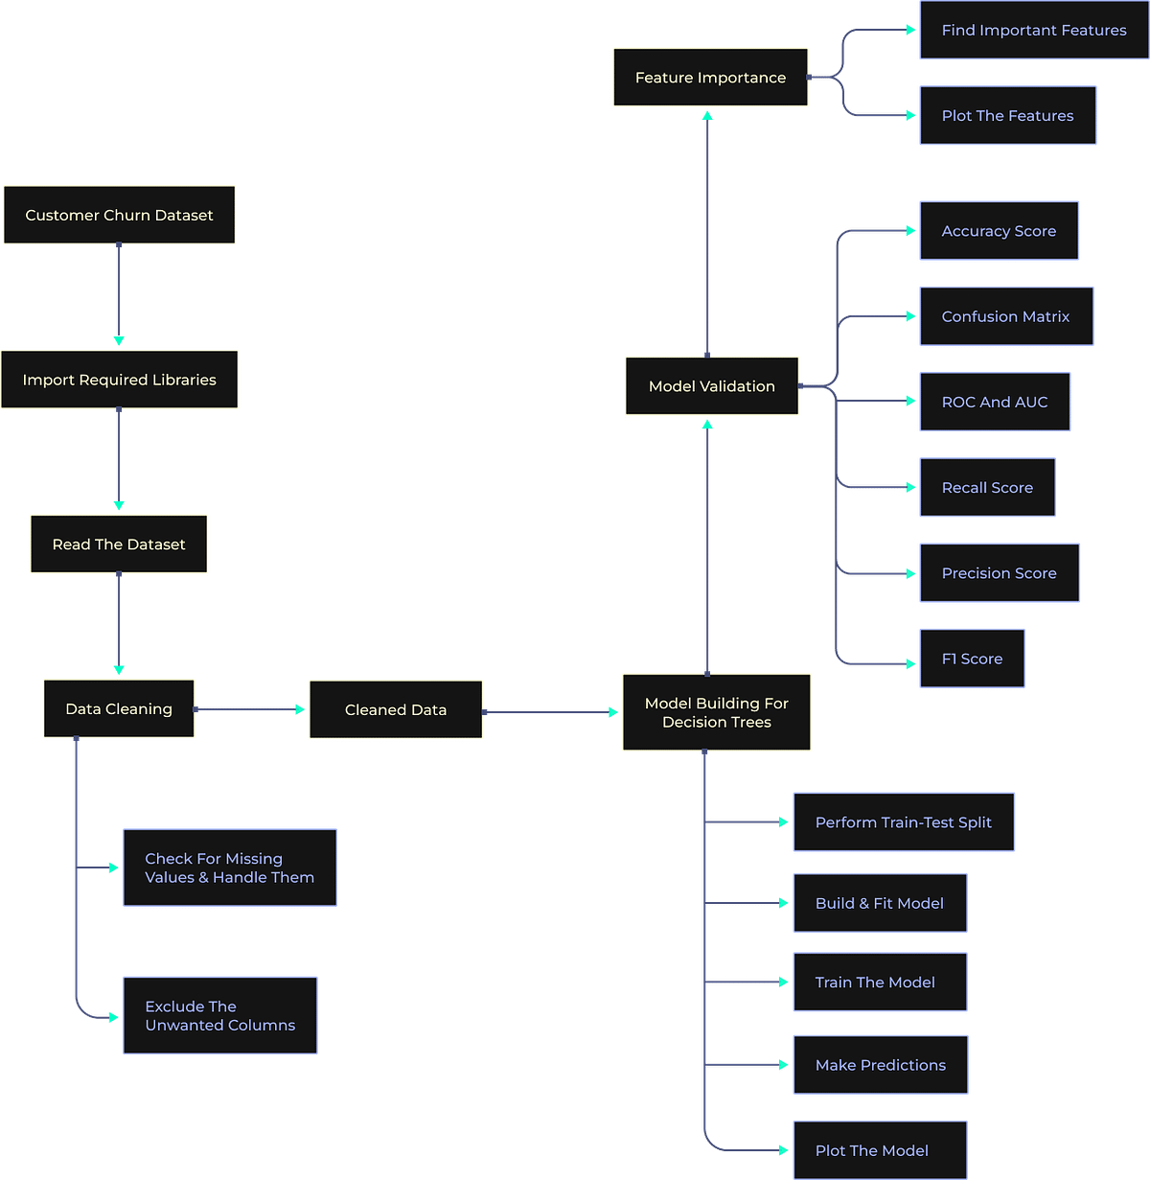

# DATASET AT KAGGLE Bank Customer Churn Prediction

<https://www.kaggle.com/datasets/shantanudhakadd/bank-customer-churn-prediction?resource=download>

SOURCE CODE :

import pandas as pd

from sklearn.model_selection import train_test_split

from sklearn.tree import DecisionTreeClassifier, plot_tree

from sklearn.preprocessing import LabelEncoder

from sklearn.metrics import accuracy_score, classification_report, confusion_matrix

import matplotlib.pyplot as plt

# Load your dataset

df = pd.read_csv('Churn_Modelling.csv')

# Identify categorical columns (assuming they are of type 'object')

categorical_cols = df.select_dtypes(include=['object']).columns

# Apply Label Encoding to each categorical column

for col in categorical_cols:

le = LabelEncoder()

df[col] = le.fit_transform(df[col])

# Assuming 'churn' is your target variable

X = df.drop('churn', axis=1)

y = df['churn']

# Split the dataset into training and testing sets

X_train, X_test, y_train, y_test = train_test_split(X, y, test_size=0.2, random_state=42)

# Initialize and train the Decision Tree model

model = DecisionTreeClassifier(random_state=42)

model.fit(X_train, y_train)

y_pred = model.predict(X_test)

# Evaluate the model

accuracy = accuracy_score(y_test, y_pred)

conf_matrix = confusion_matrix(y_test, y_pred)

classification_rep = classification_report(y_test, y_pred)

# Print the results

print(f"Accuracy: {accuracy:.2f}")

print("Confusion Matrix:\n", conf_matrix)

print("Classification Report:\n", classification_rep)

# Visualize the Decision Tree

plt.figure(figsize=(12,8))

plot_tree(model, filled=True, feature_names=X.columns, class_names=['Not Churned', 'Churned'], rounded=True)

plt.show()

#pre pruned decision tree

model1 = DecisionTreeClassifier(max_depth=4, min_samples_split=50, random_state=42)

# Train the model

model1.fit(X_train, y_train)

model1.fit(X_train, y_train)

y_pred1 = model1.predict(X_test)

# Evaluate the model

accuracy = accuracy_score(y_test, y_pred1)

conf_matrix = confusion_matrix(y_test, y_pred1)

classification_rep = classification_report(y_test, y_pred1)

# Print the results

Print(“pre pruned decision tree”)

print(f"Accuracy of pre pruned decision tree: {accuracy:.2f}")

print("Confusion Matrix of pre pruned decision tree:\n", conf_matrix)

print("Classification Report of pre pruned decision tree:\n", classification_rep)

# Visualize the pre-pruned Decision Tree

plt.figure(figsize=(12,8))

plot_tree(model1, filled=True, feature_names=X.columns, class_names=['Not Churned', 'Churned'], rounded=True)

plt.show()

#post pruned tree

model2 = DecisionTreeClassifier(max_depth=4, min_samples_split=50, random_state=42)

# Train the model

model2.fit(X_train, y_train)

model2.fit(X_train, y_train)

y_pred2 = model2.predict(X_test)

# Evaluate the model

accuracy = accuracy_score(y_test, y_pred2)

conf_matrix = confusion_matrix(y_test, y_pred2)

classification_rep = classification_report(y_test, y_pred2)

# Print the results

Print(“post pruned trees”)

print(f"Accuracy of post pruned tree: {accuracy:.2f}")

print("Confusion Matrix of post pruned tree:\n", conf_matrix)

print("Classification Report of post pruned tree:\n", classification_rep)

# Visualize the pre-pruned Decision Tree

plt.figure(figsize=(12, 8))

plot_tree(model2, filled=True, feature_names=X.columns, class_names=['Not Churned', 'Churned'], rounded=True)

plt.show()

OUTPUT:

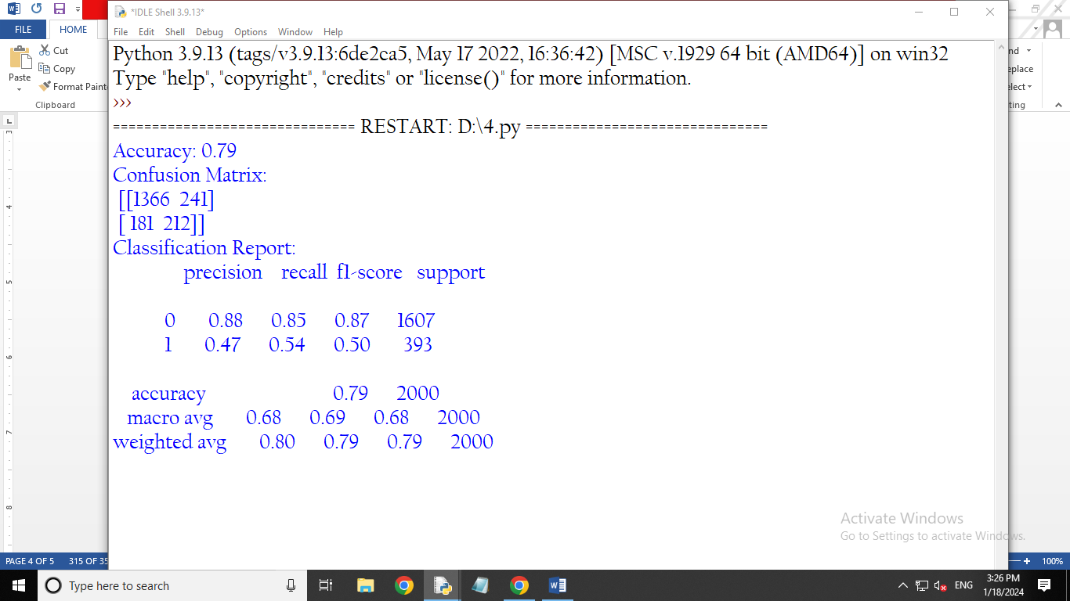

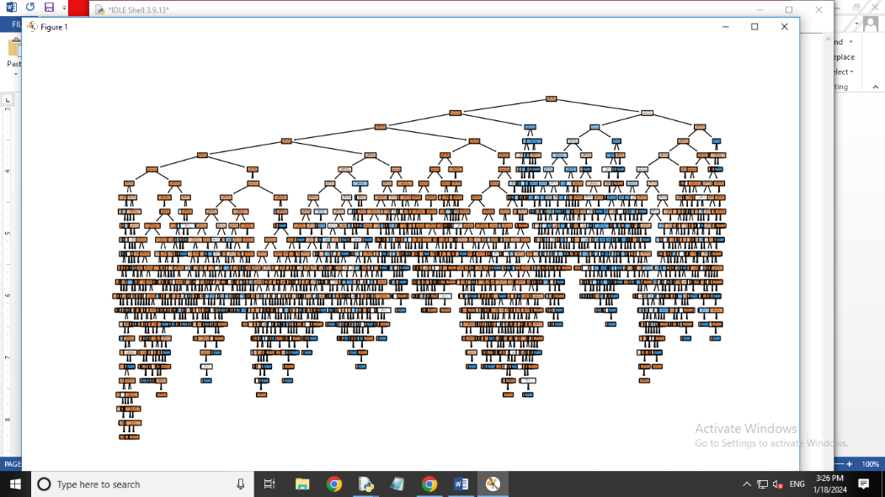

PRE PRUNED TREES:

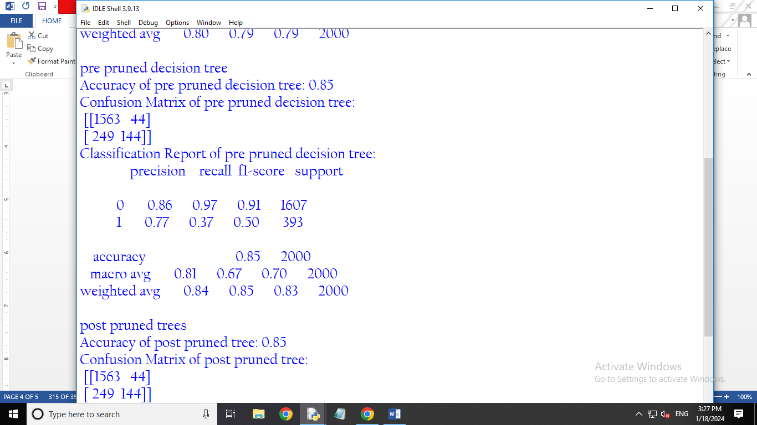

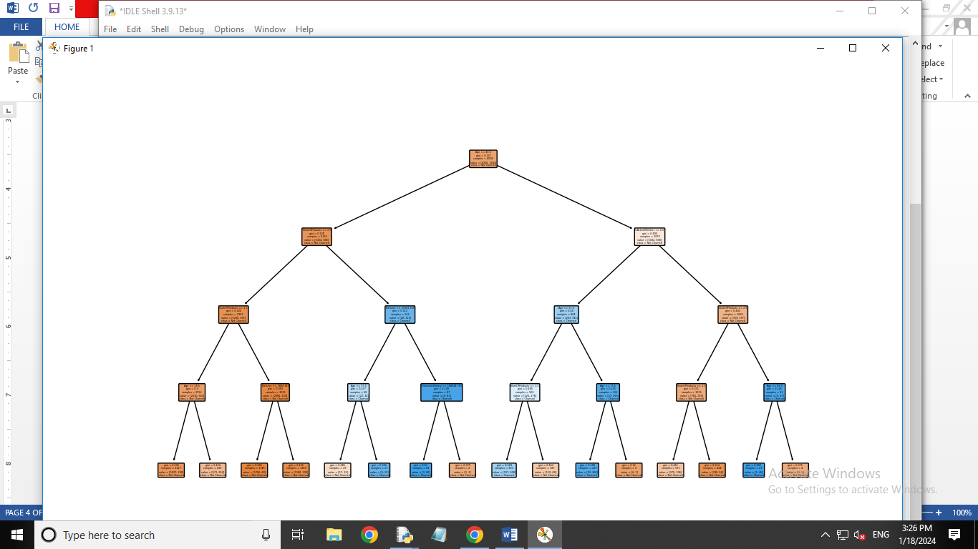

POST PRUNED TREES:

